Earlier UI directly communicate with backend but now when we moved to the cloud we have proxy in place.
When we open the UI for example on the localhost:3001 in the url, if we call up any api tha needs to be go to the backend with help of any proxy the UI will call same url bur the proxy will change to backend url localhost:5001 internally.

Because of the proxy user will never see the backend urls, will only see frontend url.
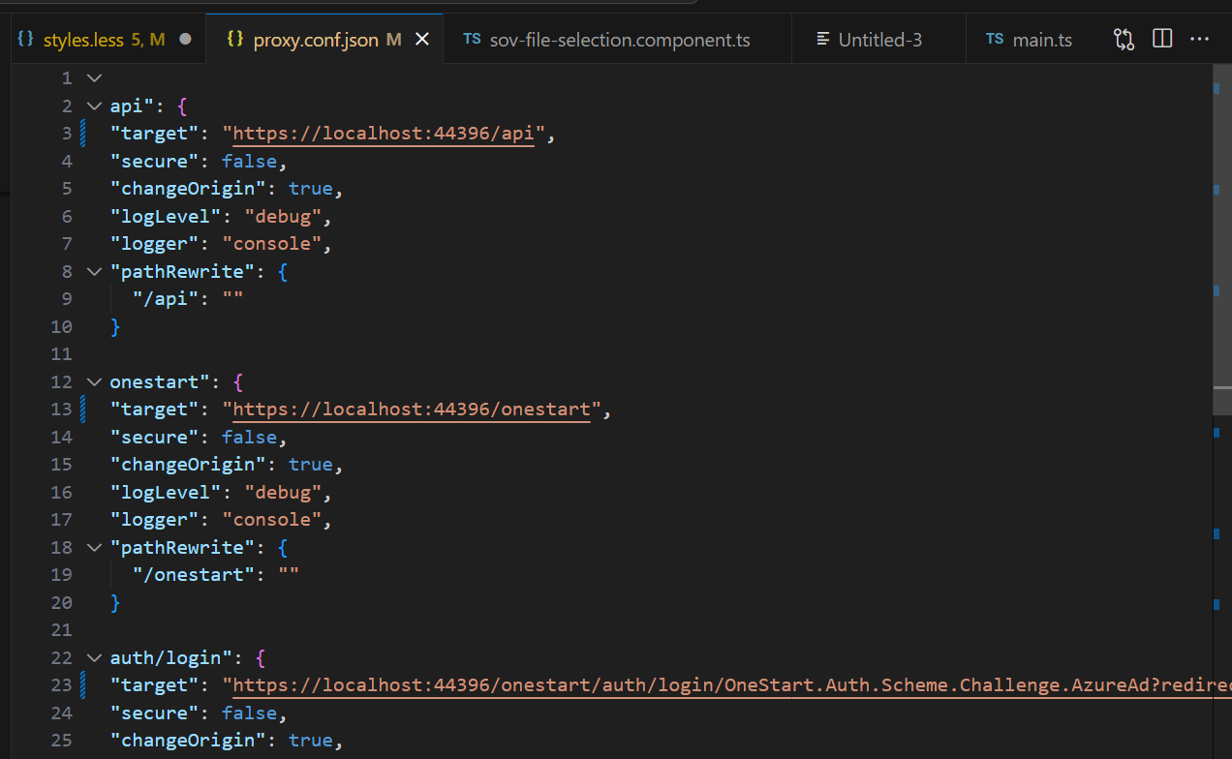

In production we have openshift that we have a linux container where the proxy is managed by the nginx.com, which is similar to proxy.conf.json used in local.

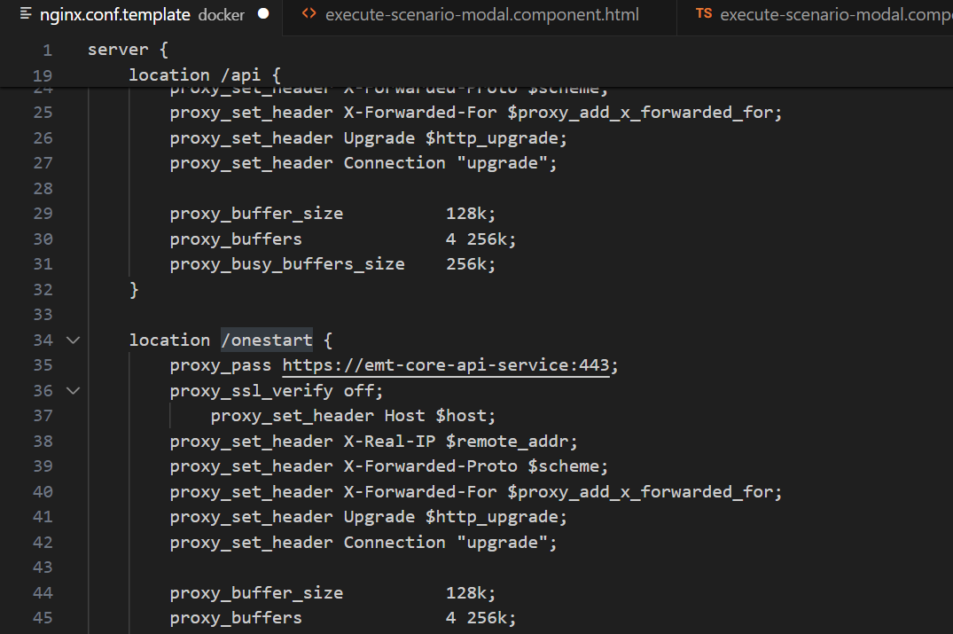

If someone hit on the url /api and the url infornt of or, then it will redirected to localhost backend url onestart which is used for SSO.

In proxy.conf.json we have post mentioned like backend 44395 frontend 44396, Incase we are changing the port then need to make changes in this file.

In EMT core server we have appsettings.json.
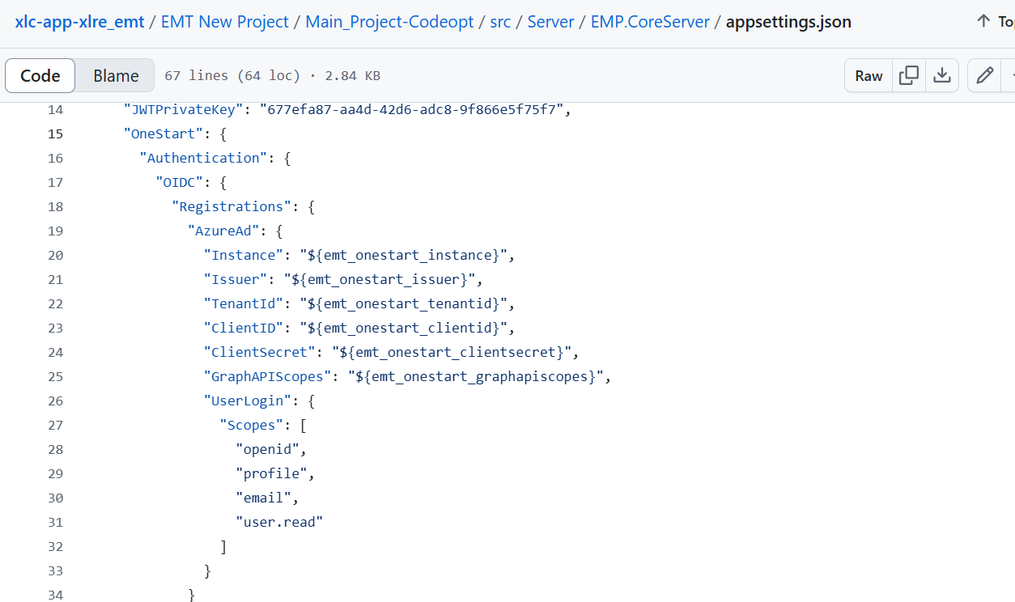
We can see here the place holder, the values will be populating from key store by Harness pipeline used by openshift.
Theses are all environment specific values.
SSO changes are done in Program.cs where we added Onestart framework library which is AXAXL library for ready made code to SSO.
When the app will login from frontend it will redirect to Microsoft, which will authenticate it and once authenticated it will get Callback. Also we are calling Graph API for get Xid.

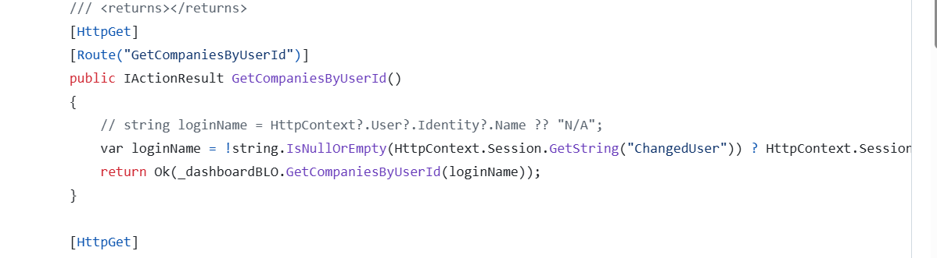

Once user is authenticated we call Graph API.
In graph api we are getting some claims values including onpremisedsamaccount name which is Xid.
We have added the below ClaimsPrinicipleExtension.cs class to handle the graph calls.
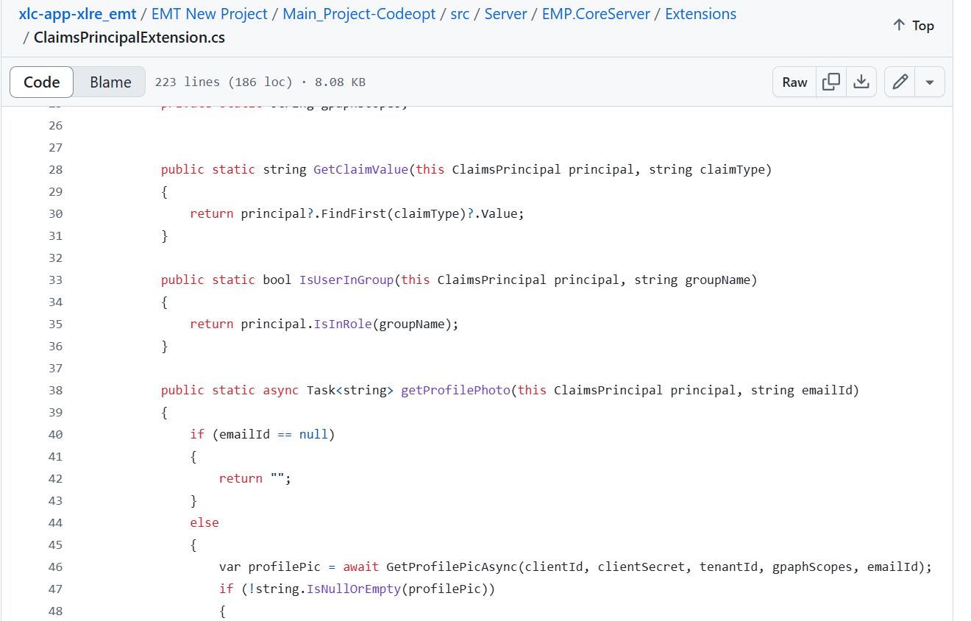

- The code defines a static class named ClaimsPrincipalExtensions to extend the functionality of ClaimsPrincipal.
- The GetClaimValue method returns the value of a specific claim type from the ClaimsPrincipal.
- The IsUserInGroup method returns a boolean indicating whether the ClaimsPrincipal is a member of a specific group.
- The UpdateXidDetailsAsync method retrieves the on-premises SamAccountName for the user and adds it as a claim to the ClaimsPrincipal.
- The method takes in parameters for Azure AD authentication such as clientId, clientSecret, tenantId, and gpaphScopes.
- The method retrieves the email and UPN from the ClaimsPrincipal and logs them.
- If the email claim is not found, the method tries to retrieve it from the Email claim type.
- The method calls the MakeGraphCallAsync method to retrieve the on-premises SamAccountName from the Microsoft Graph API.
- The MakeGraphCallAsync method authenticates with Azure AD using a client secret and retrieves the user object from the Microsoft Graph API.
- The method filters the user based on email or UPN and selects the onPremisesSamAccountName property.
- If the user is found, the method returns the onPremisesSamAccountName. If not, an exception is thrown.

